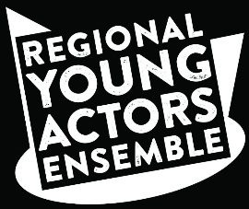
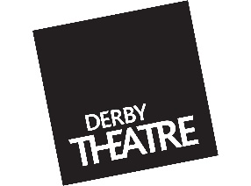
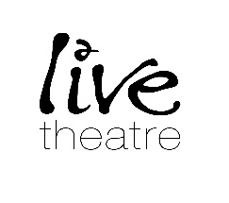
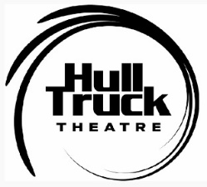

Thank you for your interest in auditioning for our brand-new project, the Regional Young Actors Ensemble piloted by Hull Truck Theatre in conjunction with Hull 2017, partnered with Live Theatre and Derby Theatre. This new pilot project is part of our 2017 celebrations and is an affordable, accessible progression route for young people into professional acting. This has been made possible by removing barriers such as fees, travel and accommodation costs, so that the project is totally 0 cost for all. Should you be successful, you will be required to attend a week of intensive rehearsal in your regional theatre, then travel to Hull in June to create a show with participants from Derby, Newcastle and Hull.
Please fill out the following application form and return it to
sarah-louise.penney@hulltruck.co.uk
Your application will then be passed to your closest regional theatre for review.
Please aim to get your application sent to us one week before your chosen audition date.

Name: ……………………………………………………………………
D.O.B: …………………………………………………………………….
Telephone Number: ……………………………………………..
Email Address: ……………………………………………………….

In your own words, please tell us why you would like to be selected for this programme including why the opportunity would be of benefit and any potential barriers you may face that would prevent you pursuing acting as a career e.g. financial, support from parents, friends or carers etc.
…………………………………………………………………………………………………………………………………………………………………………………………………………………………………………………………………………………………………………………………………………………………………………………………………………………………………………………………………………………………………………………………………………………………………………………………………………………………………………………………………………………………………………………………………………………………………………………………………………………………………………………………………………………………………………………………………………………………………………………………………………………………………………………………………
……………………………………………………………………………………………………………………………………………………………………………………………………………………………………………………………………………………………………………………………………………………………………………………………………………………………………………………………………………………………………………………………………………………………………………………………………………………………………………………………………………………………………………………………………………………………………………………………………………………………………………………………………………………………………………………………………………………………………………………………………………………………………………………………………………………………………………………………………………………………………………………………………………………

Please summarise any performance experience that you have had to date.

……………………………………………………………………………………………………………………………………………………………………………………………………………………………………………………………………………………………………………………………………………………………………………………………………………………………………………………………………………………………………………………………………………………………………………………………………………………………………………………………………………………………………………………………………………………………………………………………………………………………………………………………………………………………………………………………………………………………………………………………………………………………………………………………………………………………………………………………………………………………………………………………………………………

As part of this programme, you will be required to attend an intensive rehearsal period in your region at either Derby Theatre, (29th of May to the 2nd of June) Hull Truck Theatre, (19th to the 23rd of June) or Newcastle Live, (30th of May to the 3rd of June.) Are you available for your regional theatre’s chosen dates?
……………………………………………………………………………………………………………………………………………………………………………………………………………………………………………………………………………………………………

Participating in this project requires you to travel to Hull in the summer to rehearse for the final show as part of City of Culture. Are you available from the 20th to the 27th of August?
……………………………………………………………………………………………………………………………………………………………………………………………………………………………………………………………………………………………………

Please state any access requirements that you may have for the audition stage.
……………………………………………………………………………………………………………………………………………………………………………………………………………………………………………………………………………………………………

Please tell us your audition centre of preference.
Please be advised that the New College, Clarendon Campus, Nottingham audition has been moved to Tuesday the 25th of April, 6pm-7pm and the auditions at Derby Theatre have now been moved to Wednesday the 3rd of May, 6pm-7:30pm.
If your choice is The New Vic, please ensure to specify as to whether this is Newcastle or Derby.
……………………………………………………………………………………………………………………………………………………………

I, …………………………………………………………, understand that Hull Truck Theatre, (HTT) Hull 2017, Live Theatre and Derby Theatre will be taking photographs and video of activities and performances at its events for use within the above named photographic libraries, printed publications/publicity and on their websites, to support and promote the work of the organisations and that the copyright and ownership of the photographs will lie with the above named. I do not have any objections to this.

Participant’s signature: ______________________________ Date: ___________________

