
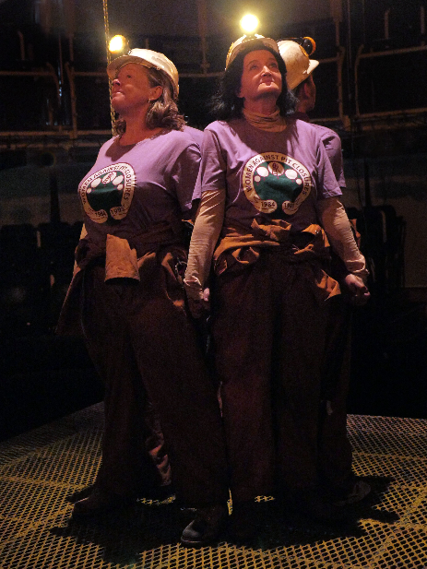
We are looking for male performers to join our Community Theatre.

We’re looking for men to join our New Vic Community Theatre, particularly for our forthcoming production of Queens of the Coal Age by Maxine Peake. Writing credits include The Last Testament of Lilliean Bilocca. Maxine’s heatre credits include Happy Days and Hamlet (Manchester Exchange). Her many TV credits include Silk, The Village (for which she was BAFTA nominated), Red Riding and See No Evil. Maxine was also BAFTA nominated for her performance in Hancock and Joan.
Based on a true story, the play follows the four women who occupy Parkside Colliery over the Easter holidays in 1993, protesting the fresh wave of pit closures announced by John Major’s Government. Set in the depths of the mine, we sit with the characters and their humour, through those remarkable four nights and five days.
The ensemble will play Miners at Parkside Colliery – from Victorian age to the 90s – and will form an integral part of the vision of the show. Working closely with creative team the ensemble will create dynamic, physical images and movement sequences that run in parallel to the action. We want to create a sense of history to in the pit, and a haunting reminder of what the women are fighting for; and what will be lost ultimately.

We are looking for men aged 18+ of any ethnicity and physique! We want to work with people’s individual capabilities, creating a diverse ensemble of men. It isn’t necessary to have previous experience of performing on stage, applicants must be comfortable with performance and up for the challenge!

The show has already undergone a successful run at Manchester Exchange (★★★★★ Northern Soul ★★★★ The Sunday Times ★★★★ The Times) this is an exciting opportunity to be part of a vital story that we are proud to be telling.
Taking part in the show does of course mean you will have to be committed to the rehearsal process and the performance schedule (see attached sheets for more info).

Following this, as part of our Community Theatre Company you will receive invitations for future opportunities to give involved in New Vic work.

If you are interested, we are holding introductory sessions with New Vic’s Assistant Director, Anna Poole, who will give you a feel for the production. It’s a chance for you to see if it’s for you and allow the team here to meet you. We will then put together our ensemble after these sessions. These sessions will be held on the evening of
Tuesday 7th August 7:00-8:30pm and Wednesday 8th August 7:00-8:30pm.

If you’re interested, please fill in the attached Application Form, Equal Opportunities Form and Media Permission Form and return them to us ASAP.
At the end of the performance run, we will issue each participant with a contribution towards expenses but taking part is on a voluntary and unpaid basis.

We do hope to hear from you.
Any questions, please contact the New Vic Admin department on 01782 717954.
Thank you.
Louise Grattage, New Vic Administration Assistant
lgrattage@newvictheatre.org.uk

Rehearsal Schedule

Date | Session | Time
Tuesday 7th August | Introduction Workshop | 19:00 – 20:30
Wednesday 8th August | Introduction Workshop | 19:00 – 20:30
Monday 20th August | Rehearsal | 19:00 – 21:00
Tuesday 21st August | Rehearsal | 19:00 – 21:00
Wednesday 22nd August | Rehearsal | 19:00 – 21:00
Thursday 23rd August | Rehearsal | 19:00 - 21:00
Monday 27th August | Rehearsal | 19:00 – 21:00
Tuesday 28th August | Rehearsal | 19:00 – 21:00
Wednesday 29th August | Rehearsal | 19:00 – 21:00
Thursday 30th August | Rehearsal | 19:00 – 21:00
Saturday 1st September | Rehearsal | 10:00 – 13:00
Monday 3rd September | Tech Rehearsal | 18:00 - TBC
Tuesday 4th September | Tech Rehearsal | 18:00 – TBC
Wednesday 5th September | Tech Rehearsal | 18:00 – TBC
Thursday 6th September | Dress Rehearsal | 18:00 - TBC
Friday 7th September | Dress Rehearsal + Performance | 12:00 – 22:00 TBC

Performances

Date | Call Time (tbc) | Show Time
Saturday 8th September | 18:00 | 19:30
Monday 10th September | 18:00 | 19:30
Tuesday 11th September | 18:00 | 19:30
Thursday 13th September | 18:00 | 19:30
Friday 14th September | 18:00 | 19:30
Saturday 15th September | 18:00 | 19:30
Tuesday 18th September | 18:00 | 19:30
Wednesday 19thSeptember | 18:00 | 19:30
Thursday 20th September | 18:00 | 19:30
Friday 21st September | 18:00 | 19:30
Saturday 22nd September | 12:45 & 18:00 | 14:15 & 19:30
Tuesday 25th September | 18:00 | 19:30
Wednesday 26thSeptember | 18:00 | 19:30
Thursday 27th September | 12:45 & 18:00 | 14:15 & 19:30
Friday 28th September | 18:00 | 19:30
Saturday 29th September | 12:45 & 18:00 | 14:15 & 19:30

Queens of the Coal Age Community Ensemble
Intro Workshop Application Form

Please fill in the form below if you are interested in taking part in the
New Vic Theatre & Manchester Exchange’s production of Queens of the Coal Age

Name:

Address:

Email Address:

Contact Phone Numbers:

1. 2.

Please indicate which workshop on you are able to attend:

Tues 7th August 19:00 – 21:00 Weds 8th August 19:00 – 21:00

I am available for the following rehearsals for Queens of the Coal Age (please highlight those you can attend):
Rehearsals
Monday 20th Aug 19:00 – 21:00
Tuesday 21st Aug 19:00 – 21:00
Wednesday 22nd Aug 19:00 – 21:00
Thursday 23rd Aug 19:00 – 21:00
Monday 27thAug 19:00 – 21:00
Tuesday 28thAug 19:00 – 21:00
Wednesday 29thAug 19:00 – 21:00
Thursday 30th Aug 19:00 – 21:00
Saturday 1st Aug 10:00 – 13:00

Tech week:
Monday 3rd Sept 18:00 end time TBC
Tuesday 4th Sept 18:00 end time TBC
Wednesday 5th Sept 18:00 end time TBC
Thursday 6th Sept at 18:00 end time TBC (dress run)
Friday 7th September at 12:00pm

Friday 7th September – Saturday 29th September – performances of Queens of the Coal Age as per the attached schedule.

Note: You will need to be available for at least 50% of rehearsals and performances.

Name:

Signed:

Number……………….

Queens of the Coal Age Community Ensemble
Media Permission Form

- I do / do not * give permission for photographs to be taken and used for archive, marketing/publicity, educational and other non-commercial use.

- I do / do not * give permission for video/sound recordings to be taken and used for archive, marketing/publicity, educational and other non-commercial use.

* Please delete as appropriate.

Name (please print):………………...………………………………………

Signature:……………………………………………………………………

Date: ……………/……………/ 2018

All material will be held in accordance with the General Data Protection Regulations and the New Vic’s Privacy Notice. Copies of the Privacy notice are available from the Head of HR & General Management.

