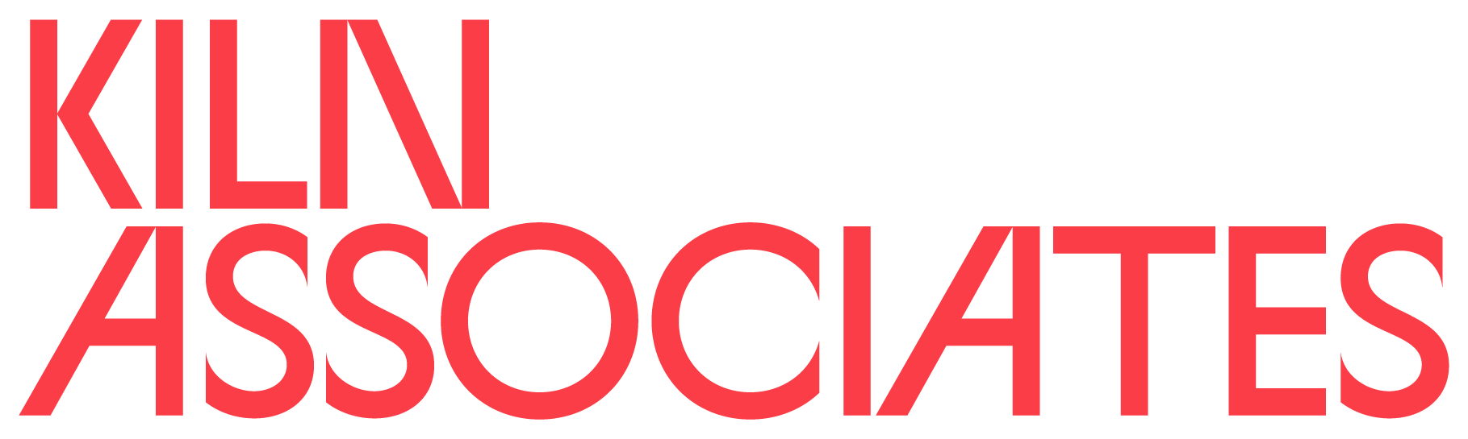

Recruitment Pack
March 2021

Thank you for your interest in the New Vic’s Kiln Associates programme.
This recruitment pack includes:
- Introduction to New Vic Theatre
- Introduction to Kiln Associates programme
- The offer
- How To Apply – Application Process and Timeline
- Kiln Network

This pack is available to download in audio and
large print/plain text formats from our website.

About the New Vic
Our mission is to make excellent theatre with a social impact.

‘Staffordshire’s New Vic proves what a regional theatre with ambition and imagination can do’
The Guardian

The New Vic is one of the country’s most successful producing theatres and a key part of the region’s cultural life, engaging over 180,000 people each year. We deliver a programme of world-class work made with local audiences in mind, complemented by award-winning community programmes and education work reaching around 25,000 people of all ages each year.

Built in 1986 as Europe’s first purpose-built theatre-in-the-round, the theatre has a special role to play in the architectural heritage of theatre development. We seek through all our work to help make our local community a better, safer and more inspiring place to live and work.

We explore new and exciting theatre through a continued programme of investment in artistic development. Our busy programme includes both award-winning, in-house work and touring productions. We produce around 8 in- house or co-produced shows a year. We have in-house set, props and costume workshops with permanent staff teams.

Our in-house programming includes our acclaimed Christmas show, drama and new writing, and our co- producing partners include amongst others Royal Exchange Manchester, Kenny Wax Family Entertainment, Oldham Coliseum, Bolton Octagon and Dukes Theatre Lancaster.

The Kiln Associates programme is led by the New Vic’s Associate Director Vicki Amedume. Vicki is an artist, facilitator and educator working across contemporary circus, outdoor arts, theatre and dance. She is Artistic Director of contemporary circus company Upswing and Chair of The Baring Foundation Arts Committee. She was formerly a circus performer and initially trained as a research scientist.

Kiln Associates – An Introduction
The New Vic is inviting three companies to become our associates for a year.

The Kiln, our artistic development programme, nurtures the development of independent companies with the aim of building a richer and more dynamic arts sector locally and nationally.

The programme, launched in 2016, has worked with a number of Associate Companies to support their development by sharing the theatre’s knowledge, experience and resources.

This year we hope to recruit three companies, each supported by an investment of £5,000, plus support in kind, to work for with us for one year from September 2021.

We are looking for companies who:
- are working in performance (including but not limited to theatre, circus, dance, outdoor arts, live art, music, opera…)
- are making exciting, innovative work that has the potential to engage our communities
- are at a place in their development where being part of the Kiln programme will make a meaningful difference to their work, company and/or practice
- feel that they can both benefit from, and actively contribute to, a relationship with the New Vic and the creative ecology in Staffordshire and Stoke-on-Trent

We are keen to ensure the Associate programme represents the range of artists in the UK, and warmly encourage applications from those who are currently underrepresented in the performing arts sector, including but not limited to, disabled artists, artists from financially disadvantaged backgrounds, artists who experience racism and artists who are LGBTQIA+.

What do we mean by a company?
- A formally constituted company
- A partnership
- An unincorporated group or collective
- A lead artist, creative or producer working with collaborators

The Associateship is not intended to support only a single artist. We would expect recipients to use the funds offered in part to pay themselves and their collaborators fees appropriate to industry standards within their arts practice.

We are not able to support:
- Applicants who are currently in undergraduate or full-time postgraduate education
- Applicants who have less than one year of professional experience

Place:
The New Vic’s location gives us a strong sense of place, but we also belong to a national ecology and, increasingly, our theatremaking has a national and an international dimension. Our intention is that:
- One of our Associates will be locally based (by which we mean Staffordshire, Newcastle-under-Lyme and Stoke-on-Trent)
- One will be regional (we are defining this as a 25-mile radius from the New Vic - including to companies based in Staffordshire, Stoke-on-Trent, North Shropshire, East Cheshire)
- One will be national (based anywhere in the UK)

With regional and national companies, we are prioritising organisations that bring artists or artistic practices that are underrepresented in the Staffordshire and Stoke-on-Trent area.

The Offer
This is not a commission. We are offering a year-long relationship with the New Vic to give your company space and time to enable artistic ideas and/or practices to flourish.

You may decide that you want to use the time to develop a new idea, or to re-imagine an old one, you may want to explore participatory practice or develop a digital performance. Primarily we want your focus to be developing artistic ideas, but if time is needed to develop your company’s structure that is also welcome.

We recognise that each company will be different and have needs dependant on the type of work they make, their ambition, their experience, and the barriers they may face along the way.

Each company will receive:
- A £5,000 investment plus support in kind
- Access to meeting space where possible
- Up to 2 weeks development space within the building. This is likely to be distributed through the year or in specific periods such as December 2021, April 2022 and June-August 2022 (exact dates and structure to be agreed with successful applicants)
- Access to advice and support from New Vic staff. This may include technical support; advice and help with business planning, budgeting, fundraising and marketing. (exact offer to be agreed with successful applicants)
- Opportunities to observe work/rehearsals where appropriate.
- Invitations to Guest Nights for our in-house productions.
- The opportunity to attend events for our wider artists hub, the Kiln Network

We will work with each company to plan their year at the start of the Associateship, and we will schedule regular check points to follow up on progress.

Please note: The £5,000 investment is intended to cover all expenses incurred by an associate company’s involvement including travel

What we ask of our associate companies:
- Companies are asked to offer one workshop to the New Vic’s wider Artist’s hub scheme during their residency.
- We hope that companies will bring new energies to the New Vic building and workforce
- Acknowledge the New Vic’s support in your online presence and social media, and future work that emerges from the Associateship

How to Apply

The guidelines and application forms are available in large print, plain text format and an audio format from our website.

The application process is in two-stages:

Stage 1: The first stage is an expression of interest by completing the short application form or by sending in a short video or audio application answering the same questions.

Stage 2: From these expressions of interest, we will invite a new submission from a small number of shortlisted applicants to expand on their proposal, in discussion with the New Vic. We will provide a small stipend of £150 to complete the second stage of the application process.

Timeline
- Deadline for Expression of interest 10am Monday 17 May 2021
- Shortlisted candidates will be contacted during week beginning
Monday 14 June 2021
- Shortlisted candidates will be asked to return a more developed proposal by 10am Monday 5 July 2021 and meet the New Vic team to discuss their proposal in week beginning Monday 12 July.
- The successful applicants will be confirmed by Friday 30 July 2021.
- The residency will begin in mid September 2021

We expect a high volume of applications and may not be able to respond with individual feedback to every applicant. We understand the importance of transparency on decision making and will, once Associates have been appointed, publish information on how final decisions were made and why the selected associates were chosen.

To request an application form, e-mail recruitment@newvictheatre.org.uk or download from https://www.newvictheatre.org.uk/about-us/careers/vacancies/

Alongside the associates programme, the New Vic is launching the Kiln Network.

The Kiln Network is a new programme offering talks, advice, inspiration and real and virtual gathering places for local performance-based creatives and industry professionals. Open to any performing arts professional based in the Staffordshire and Stoke-on-Trent area, Network members can be at any stage in their career from early-career to established and experienced.

To sign up for the network and receive details of the hub launch events in May please fill in the sign up form, available on our website. If filling in forms is a barrier please email admin@newvictheatre.org.uk for an alternative way to sign up

For more information or assistance

To find out more about the New Vic Theatre visit our website www.newvictheatre.org.uk

If you have any queries regarding this guidance please email recruitment@newvictheatre.org.uk

The New Vic Theatre operates thanks to a unique partnership between Arts Council England, Newcastle-under-Lyme Borough Council,
Staffordshire County Council and Stoke-on-Trent City Council.

